HCI Specification

for the

Unmanned
Control & Tracking System
(UCATS)

DJ³K Team

Kurt Chewning
Jennifer Greene
Dave Manley
Jeanette Smith
John Smith

Sponsors: Dr. Kuo-Chu Chang
&
Ashwin Samant

Department of Systems Engineering & Operations Research
SYST 798 Applied Project Course
Fall 2009

TABLE OF CONTENTS

1.0 Introduction 3
2.0 HCI Design Considerations and Analysis of Alternatives 3
2.1 User Display Notifications AoA 3
2.2 Initial Mock up Windows 3
2.3 Usability Survey 3
2.4 Survey Results and New Design Considerations 3
3.0 Refined Windows Description 3
3.1 UCATS HCI Window Concept 3
3.2 TOI Parameter Tab 3
3.3 UAV Parameters Tab 3
3.4 UAV Data Tab 3
4.0 Video Display 3
5.0 Hardware Configuration 3
6.0 Final HCI Solution and Conclusion 3
APPENDICES 3
APPENDIX A: Acronyms 3
APPENDIX B: Initial Usability Survey Results 3
APPENDIX C: Second Usability Survey Results 3

1.0 Introduction
This document summarizes the Human Computer Interface (HCI) specification for the Unmanned Control & Tracking System (UCATS). The process used to determine the HCI design and usability analysis for the UCATS includes:
- Conduct initial HCI Analysis of Alternatives to develop initial HCI Design.
- Develop usability and conduct usability survey on initial HCI Design.
- Analyze survey data; modify any operational requirements based on user inputs, and produce draft HCI design.
- Verify and validate HCI design satisfies operational requirements through user surveys.
There are several Analysis of Alternative (AoA) mini studies described in this document. Several design considerationsmust be contemplated when developing HCI. The DJ³K team analyzed the stakeholder needs and stakeholder criteria as defined in the UCATS Stakeholder Value Mapping document. The team evaluated the criteria and assigned each a weight for the purpose of designing an HCI. The criteria and weights selected for the purpose of designing an HCI are described in Table 1 below.

NEED  # | STAKEHOLDER VALUE MAPPING CRITERIA | WEIGHT | Rationale for Weight
1 | Accuracy: The accuracy of information the UCATS provides. | NA | The HCI will display whatever is given to display from the other SW portions of UCATS. NA for this study.
2 | Affordability: A cost-effective solution to command and control UAVs. | .2 | The HCI design should be affordable.
3 | Safety: Safety of personnel and the urban community. | NA | The final HCI design includes an Abort function. Not included in this study.
4 | Security: Communication and operational security. | NA | Encryption and security handled by other parts of UCATS. All HCI designs include user login and passwords. NA for this study.
5 | Reliability: Reliability is the probability the UCATS will function as designed without failures and/or outages. | NA | This is important for SW and HCI design, but weight is low for designing HCI look and feel. NA for this study.
6 | Maintainability: To keep the UCATS in good repair. | .2 | The HCI design shall be maximize maintainability.
7 | Transparency of Operations: The ability to “see” how the UCATS components are functioning. | NA | No requirements defined to meet this. Not included in this study.
8 | Usability: How easy the UCATS is to use. | .4 | The most important factor in HCI design.
9 | Availability: How often UCATS is available for use. | NA | The UCATS Ao requirement is met by the SW and redundant HW components. Not included in this study.
10 | Interoperability: How easy it is for UCATS and UAVs to exchange information and use the information that has been exchanged. | NA | The Comms module interfaces with the UAV. Not part of this study.
11 | Portability: How readily transportable the UCATS C2 station from one location to another. | .1 | Included in the video display study.
12 | Reproducibility: The ability for UCATS to generate the same outputs given identical inputs. | NA | The HCI will display data from UCATS main executable. Not included in this study.
13 | Performance: UCATS will perform according to the design. | .1 | The HCI shall update the screens in a timely manner to meet SRS requirements.
14 | Flexibility: The ability of the UCATS design to adapt when external changes occur. The ease with which the UCATS can respond to uncertainty in a manner to sustain or increase its value delivery. | NA | The HCI design shall be easy to modify. NA for this study as Maintainability of the HCI is covered by this study.
15 | Extensibility: The ability of the UCATS design and implementation to take into consideration future growth. A systemic measure of the ability to extend the UCATS and the level of effort required to implement the extension. | NA | The HCI design shall be easily extensible. NA for this study as this is covered under Maintainability of the HCI.
Table 1: HCI AoA Criteria

After identifying the criteria for evaluating HCI design the DJ³K team developed a scoring system, or scale, for scoring each design. The scoring scale ranges from zero to three. If a design alternative is given a value of three, the design best satisfies the criteria. A value of zero is given if the design adds no value or does not solve the design problem. Table 2 below shows the scoring scale.

Value | Description
3 | Design consideration best meets design criteria.
2 | Design consideration meets the criteria needs but is not the best deign choice.
1 | Design consideration does not meet all the intent of the criteria and is the worst of the considerations.
0 | Design consideration fails an operational requirement or does not satisfy the intent of the design.
Table 2: HCI AoA Scoring Scale

2.0 HCI Design Considerations and Analysis of Alternatives

2.1 User Display Notifications AoA
The first consideration when developing initial window mockups was how to display user notifications. The UCATS has several notifications which need to be displayed to the operator. Before initial window mockups could be developed the DJ³K team had to determine how to display user notifications. An example of a user notification is the UAV is searching for target of interest (TOI) message. The team brainstormed and came up with two options to evaluate for user notifications.

The two options are the use of dialog pop-ups or the use a notifications area or box on a window. The dialog pop-up design would include a user message and a button to acknowledge the message. The other design option is to include a notifications area or list. This area would also include an acknowledge button for the system to confirm that the user received the message. Table 2 below shows the outcome of this mini trade study. As can be seen, the team decided to use a notifications area for the initial window designs. The main factor was the team felt bombarding the user with notifications in the form of dialogs would cause the system to be unusable. In addition having a single area to display alerts is more portable, maintainable from a SW perspective, and cheaper to implement.

 | Affordability | Maintainability | Usability | Portability | Performance | Total
Option 1: pop-ups | 1 | 1 | 1 | 1 | 2 | 1.1
Option 2: notification area | 3 | 3 | 3 | 3 | 2 | 2.9
Table 3: HCI User Notifications AoA

2.2 Initial Mock up Windows
After the first AoA, the DJ³K team developed a set of mockup windows using Microsoft PowerPoint. These mockup windows were a combination of the graphical user interface (GUI) prototype developed by Mr. Ashwin Samant and a set of windows the team developed as a vision of the final product. It should be noted that, for the purposes of the specification, the GUI prototype being developed may or may not be used in the final product. The GUI prototype development is used to evaluate the usability options of the UCATS system. The following seven figures below are the initial mockup windows.

Figure 1: UCATS Login Window

Figure 2: UCATS Initial TOI Parameters Window

Figure 3: UCATS UAV Parameters Window

Figure 4: UCATS Summary Window

Figure 5: UCATS Map Window

Figure 6: UCATS GUI Prototype Window

Figure 7: UCATS Data Entry Window

2.3 Usability Survey
After the initial mockup windows were developed, a draft usability survey was developed. This survey was developed to determine whether or not, from a usability standpoint, the HCI design was adequate. Table 4 below shows the example survey. The mockup windows were shown to a team of expert HCI developers. The mockup windows were shown to a group of three HCI experts.

Purpose: Validate the HCI design is usable and meets all user requirements
HCI Design Specification Usability Assessment
Question | Evaluation | Comment
Was the information provided in an understandable manner? | Yes No N/A
Was it easy to enter initial TOI information? | Yes No N/A
Was it easy to enter initial UAV information? | Yes No N/A
Was it easy to view map information and UAV routes? | Yes No N/A
Was it easy to view TOI routes? | Yes No N/A
Were to UAV to TOI assignments clear and understandable? | Yes No N/A
Were alerts and notifications clear and provide valuable information? | Yes No N/A
Were the alerts displayed in a readable manner? | Yes No N/A
Was it easy to open the map and view UAV and TOI routes? | Yes No N/A
Were no-fly zone clearly displayed? | Yes No N/A
Were the window operations easy to perform and usable? | Yes No N/A
Was the video display easy to view? | Yes No N/A
Would you use this system to Command and Control UAVs? | Yes No N/A
Does this system meet all your needs as the end user? | Yes No N/A
Table 4: UCATS Verification Survey

2.4 Survey Results and New Design Considerations
The initial survey results are shown in Appendix A of this document. Overall the results were quite negative. However, in the long run, this was a very worthwhile exercise. The HCI experts were quite concerned with usability and user attention management. They also introduced the DJ³K developer to the concept of “hooking.” This concept provided a way to “hook” windows together to allow the user to maintain awareness of the system while at the same time making the system more usable. The experts also felt tabs should be used instead of multiple windows. For example, the user should be able to tab to different areas when the user entered data. The user could have a TOI tab and a parameters tab to enter data. The team also felt that the map should be fixed and displayed at all times. The HCI team of experts also felt that the use of floating windows was inappropriate. For usability and attention management purposes, windows should be fixed and should not be resizable, or movable by the user.

The DJ³K team took the results of the survey and inputs and decided to create a new set of windows which incorporated the GUI maps being developed as part of the prototype. Also, the windows would be constructed with tabs and employ the “hooking” concept.

3.0 Refined Windows Descriptions
The DJ³K team took the results of the survey and inputs and decided to create a new set of windows which incorporated the GUI maps being developed as part of the prototype. Also the windows would be constructed with tabs and employ the “hooking” concept. The windows were also developed with a GUI builder instead of PowerPoint.

3.1 UCATS HCI Window Concept
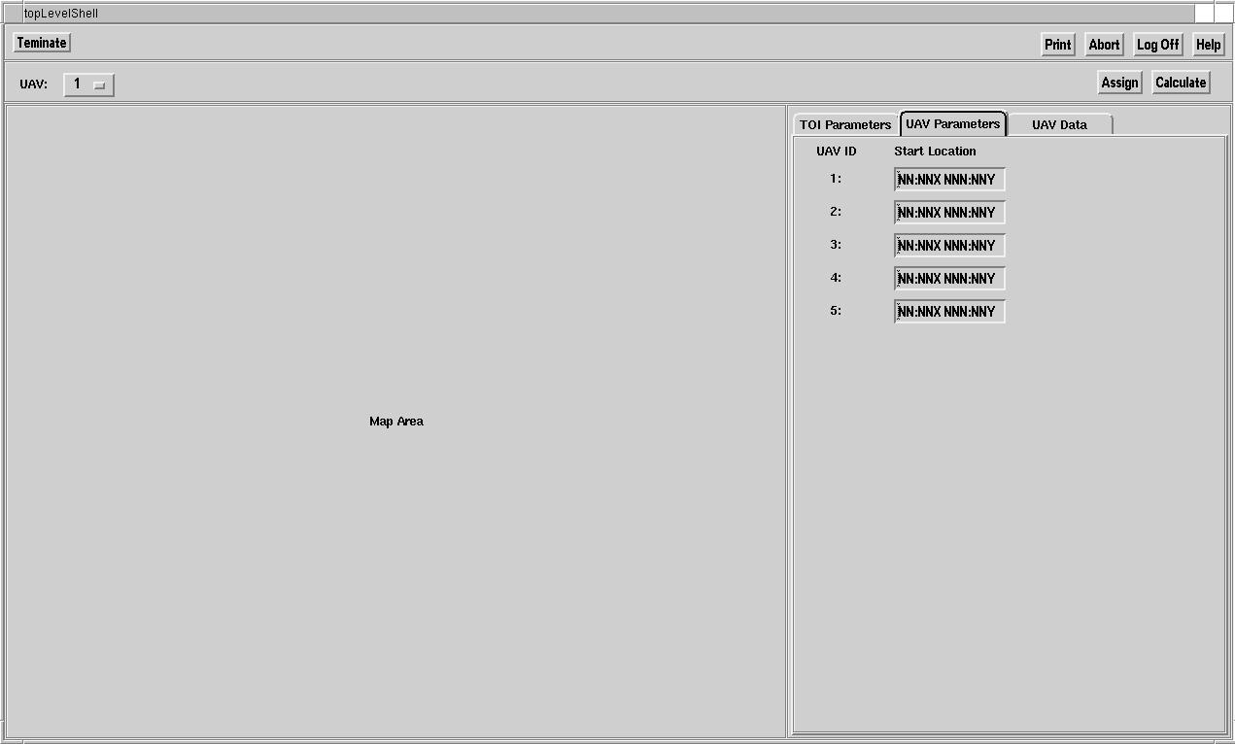
Figure 8: UCATS Main Window Concept

The UCATS window concept is a single window with four areas. The top area is the Main Menu Area with five buttons. This area is always displayed and cannot be covered at any time. The buttons in this area are the Terminate, Print, Abort, Log Off, and Help. The Terminate button terminates the UCATS and all underlying processes. The Print button prints the current window and current map. The Abort button allows the user to abort any UAV mission. When selected, this will cause a message to be sent to each tracking UAV to abort. The UAVs will stop tracking and return to a mission return location. Log Off will terminate the HCI processes on UCATS. The underlying processes will continue to run. The UCATS system will still receive and process data from the UAVs. The Help button connects the user to help information.

The next area of the UCATS HCI is the Main Function area. The area contains three buttons. This area cannot be covered by any other windows. The first button is a UAV button. This is actually a toggle button which allows the operator to select the UAV ID. The user selects a UAV number between 1 and 5. This “hooks” the Map area and UAV Data Area. If one is selected the Map Area shows the UAV 1 route and the UAV Data tab is populated with data from UAV 1. The next button is the Assign button. When pressed, this button executes the algorithm which assigns UAVs to TOIs. The results are displayed in the UAV Data tab. The calculate button executes the algorithm which computes a UAV route. The results are also displayed in the UAV Data tab.

The Map Area of the window shows the Map. This Map interface is currently an interface to Google Earth and Google Maps. The Map shows the local area, the TOI route, UAV route, and any no-fly zones.

The final area is the details area. This area contains three tabs: the TOI parameters tab, UAV parameters tab, and the UAV Data tab. The UAV Data tab is “hooked” to the Map Area display. The data in the details area is described in the sections below.

3.2 TOI Parameter Tab
Figure 9 below shows the TOI Parameters tab. In this tab the user is able to enter, view, or modify any initial TOI parameters. The user enters a start location, stop location, and priority for each TOI. The data will display on the Map Area. When the user selects the calculate button the UCATS will determine the estimated TOI route.

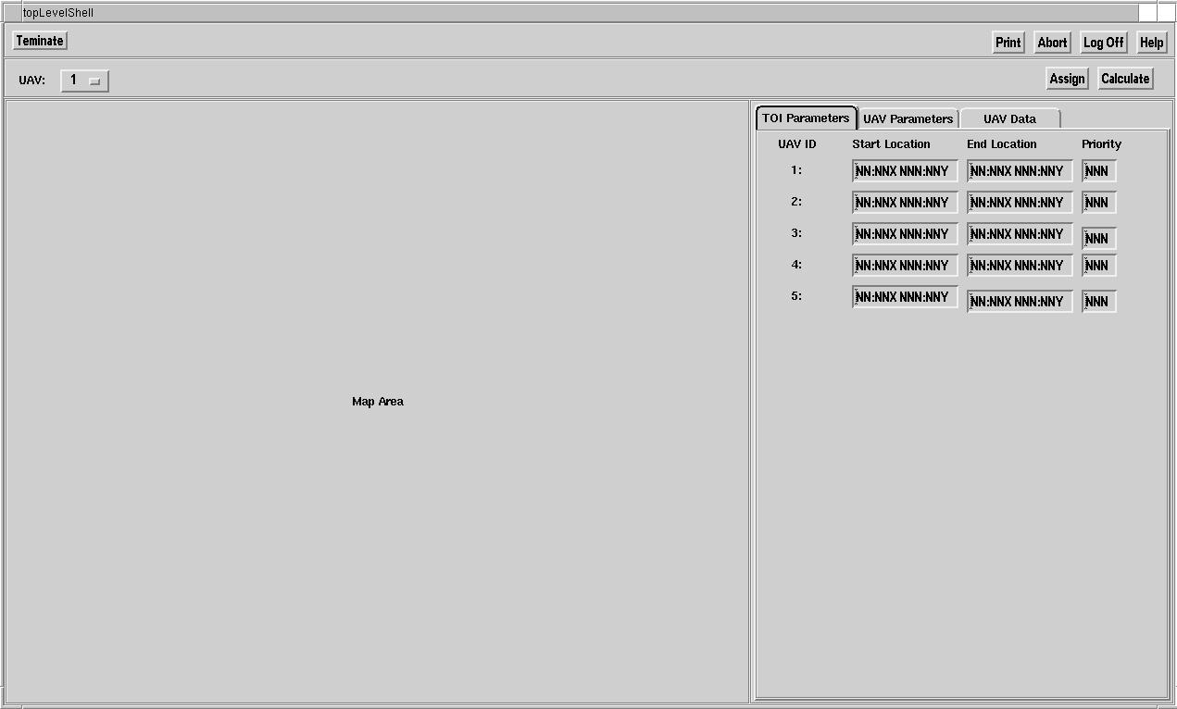
Figure 9: UCATS TOI Parameters Tab

3.3 UAV Parameters Tab
Figure 10 shows the UAV parameters tab. When the user selects the UAV Parameters tab, the user is given the ability to enter the UAV starting location. Once the system has the TOI initial parameters and the UAV initial parameters, the user can calculate initial UAV routes or assign UAVs to TOIs. The user selects either the Assign button or the calculate button from this tab. The data in the tab is also “hooked” to the Map Area as the UAV initial start location will be displayed on the map. The user can also click in the map Area to add the start

Figure 10: UCATS UAV Parameters Tab

3.4 UAV Data Tab
Figure 11 below shows the UAV data tab. The top area of the UAV Data tab contains the Approve Route button, the TOI Assignment ID, and the Priority of the TOI being tracked. The operator can approve the recommended route by selecting the approve route button. The TOI Assignment ID is displayed with the recommended TOI assignment. The field may be changed by the user if the user disagrees with the recommendations of UCATS.

The Route Area contains the UAV route. This route may be modified by the user on the map or by editing the waypoint fields. The UCATS calculates and displays up to three waypoints.

The TOI description area is populated with data received from the Tasking Authority. This is displayed in a free text area which is editable by the operator.

The notifications area contains the user notification for the UAV. This area contains a button to acknowledge a notification when the notification is selected.

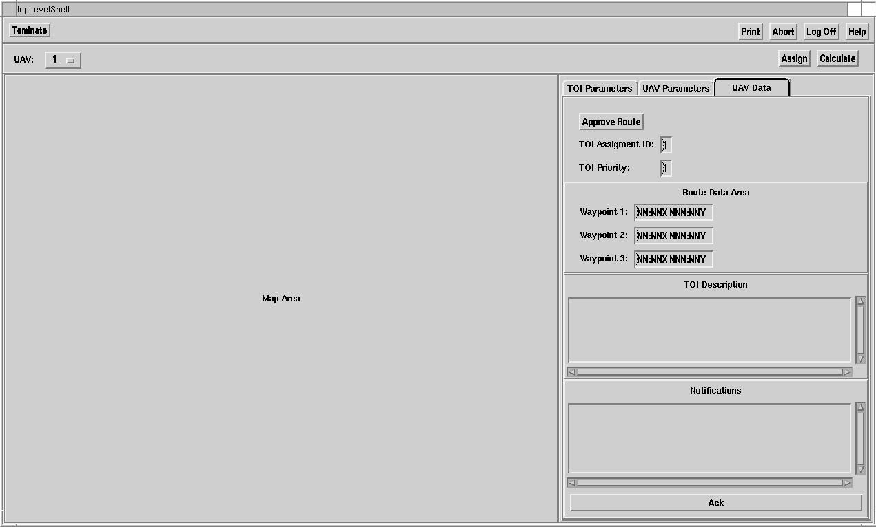
Figure 11: UCATS UAV Data Tab

4.0 Video Display
The UCATS must also display video to the operator. The team came up with three different options to display the video to the operator.

Option 1 was to display all five UAV videos on five different screens. Option 2 was to display five different UAV videos on a single screen. Option 3 was to display a single video on a single screen allowing the operator to select and change between which UAV video to display. The results of this AoA are in Table 5.

 | Affordability | Maintainability | Usability | Portability | Performance | Total
Option 1 (5 screens) | 1 | 2 | 1 | 0 | 1 | 1.1
Option 2 (single screen five displays) | 0 | 0 | 1 | 2 | 2 | .8
Option 3 (single screen one display) | 3 | 3 | 3 | 2 | 3 | 2.9
Table 5: UCATS Video Display AoA

Based on the AoA, the DJ³K team selected Option 3 to display the Video. Option 1 failed for portability and several reasons. This option would have required moving five displays. This option would require much more hardware than the other options. This option was also considered hard to use from an operators standpoint. The team felt Option 2 would be difficult to use and the screen display would be unreadable by the user. Option 2 would be the most expensive as it would require a SW solution to display all the screens and require SW to allow the user to change between the screens. Option 2 required less HW but the SW costs outweigh the HW costs. Option 3 scored the best. This option is the most affordable and easy to use. This solution is also the most maintainable from a SW perspective. Therefore Option 3 was selected.

5.0 Hardware Configuration
Based on the AoA for video, the UCATS will require two video screens to display information. The UCATS will require a user operations screen and a video screen. In order to meet the operational availability requirement the DJ³K determined that a second user operations screen would be needed. This second screen would be a passive HW component which is only used in an event the primary screen was to fail.

The HW needed is three 25 inch LCD displays for the user operations screens. The cost of each is estimated at $300 each. The final HW component is a simple 5-1 media input switch. The 5-1 switch has an estimated cost of $60. The total cost of the HW is $1260.

6.0 Final HCI Solution and Conclusion
Team DJ³K performed a second usability study based on the refined windows from Section 3. The results of the study are in Appendix C. Based on this second study the HCI design was further refined and is seen in Figure 12 and Figure 13 below. The changes to the HCI design are described in the paragraphs which follow.

From the second surveys the UAV toggle button has been replaced with UAV individual buttons. These buttons are displayed as 1,2,3,4, and 5. Anytime a user needs to view UAV data the UAV button will turn black indicating action is required. The terminate button was removed since this was functionality which was not required. Log off will terminate UCATS functions. The remaining main menu buttons were moved left to give the windows a more familiar look and feel. The two initial parameters tabs were combined due the amount of unused real estate in the tabs. There is now a single initial data tab. This tab also has an assign all button and a calculate button. These buttons when pressed either assign all UAV to TOIs or calculate all UAV and TOI routes.

Based on some new requirements from a meeting in Fairfax with the sponsor some additional data is displayed on the UAV data tab. This data is the UAV position, UAV speed and UAV heading. There is also a display for the TOI heading. Based on input from Dr. Speller there is an additional Verify Correct TOI button which allows the user to verify that the UAV is tracking the correct TOI. Text has been added to give an example of an alert and also a TOI description. The final addition is the Map interface. This allows the end users to view the vision for the end system look and feel.

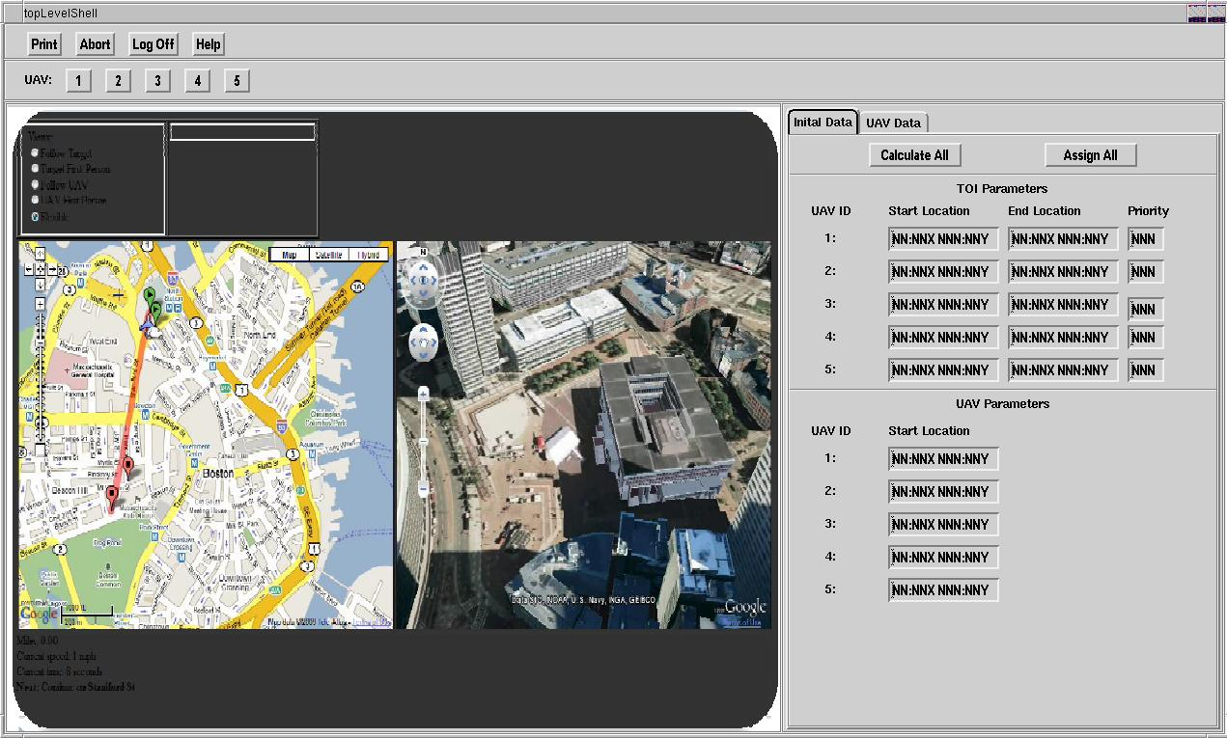
Figure 12: UCATS Initial Data Tab

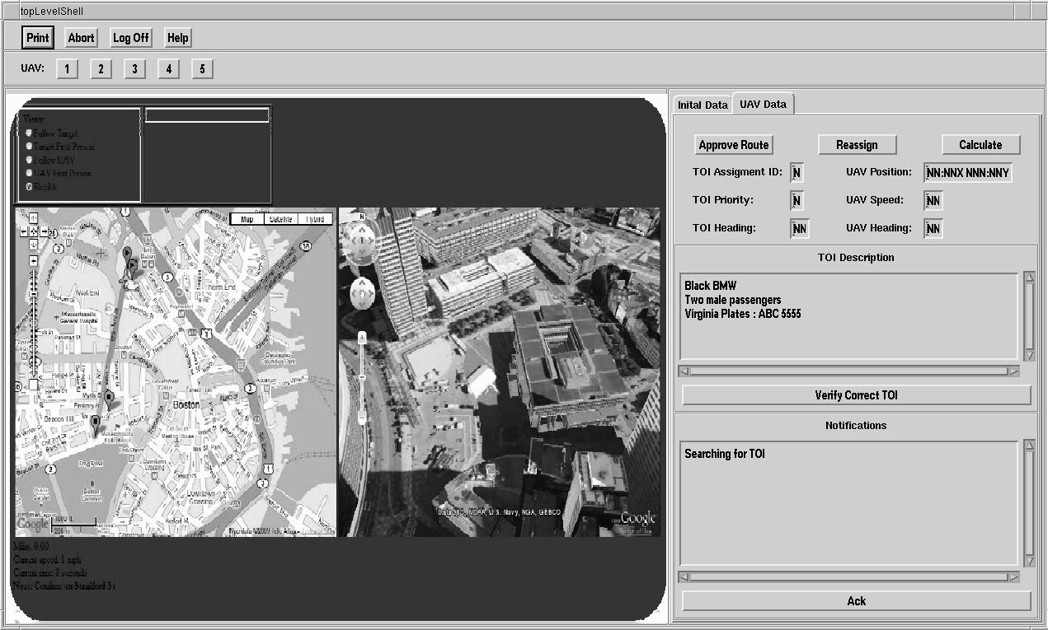
Figure 13: UCATS UAV Data Tab

APPENDICES

APPENDIX A: Acronyms

AoA Analysis of Alternatives
GUI Graphical User Interface
HW Hardware
UAV Unmanned Aerial Vehicle
UCATS Unmanned Control & Tracking System
TOI Target of Interest
SW Software

APPENDIX B: Initial Usability Survey Results
UCATS User Interface Verification Survey -1
Purpose: Validate the HCI design is usable and meets all user requirements
HCI Design Specification Usability Assessment
Question | Evaluation | Comment
Was the information provided in an understandable manner? | Yes No N/A
Was it easy to enter initial TOI information? | Yes No N/A
Was it easy to enter initial UAV information? | Yes No N/A
Was it easy to view map information and UAV routes? | Yes No N/A
Was it easy to view TOI routes? | Yes No N/A
Were to UAV to TOI assignments clear and understandable? | Yes No N/A
Were alerts and notifications clear and provide valuable information? | Yes No N/A
Were the alerts displayed in a readable manner? | Yes No N/A
Was it easy to open the map and view UAV and TOI routes? | Yes No N/A
Were no-fly zone clearly displayed? | Yes No N/A
Were the window operations easy to perform and usable? | Yes No N/A
Was the video display easy to view? | Yes No N/A
Would you use this system to Command and Control UAVs? | Yes No N/A
Does this system meet all your needs as the end user? | Yes No N/A

Comments:
This is a good start but more data is needed. Issues with viewing the routes on the map. How is the map connected to the windows. Need to hook the two together. Right now the system is not usable. Use a GUI tool to create windows not PowerPoint.

UCATS User Interface Verification Survey - 2
Purpose: Validate the HCI design is usable and meets all user requirements
HCI Design Specification Usability Assessment
Question | Evaluation | Comment
Was the information provided in an understandable manner? | Yes No N/A
Was it easy to enter initial TOI information? | Yes No N/A
Was it easy to enter initial UAV information? | Yes No N/A
Was it easy to view map information and UAV routes? | Yes No N/A
Was it easy to view TOI routes? | Yes No N/A
Were to UAV to TOI assignments clear and understandable? | Yes No N/A
Were alerts and notifications clear and provide valuable information? | Yes No N/A
Were the alerts displayed in a readable manner? | Yes No N/A
Was it easy to open the map and view UAV and TOI routes? | Yes No N/A
Were no-fly zone clearly displayed? | Yes No N/A
Were the window operations easy to perform and usable? | Yes No N/A
Was the video display easy to view? | Yes No N/A
Would you use this system to Command and Control UAVs? | Yes No N/A
Does this system meet all your needs as the end user? | Yes No N/A

Comments:
System presented would be unusable. Floating windows are not a good idea. Recommend using fixed windows. How the map is incorporated is unclear. Also recommend using tabs to enter data and a single window. Always display the map. Alerts and notifications are not clear how this would work. Video was not shown.

UCATS User Interface Verification Survey -3
Purpose: Validate the HCI design is usable and meets all user requirements
HCI Design Specification Usability Assessment
Question | Evaluation | Comment
Was the information provided in an understandable manner? | Yes No N/A
Was it easy to enter initial TOI information? | Yes No N/A
Was it easy to enter initial UAV information? | Yes No N/A
Was it easy to view map information and UAV routes? | Yes No N/A | No connection between Map and Windows
Was it easy to view TOI routes? | Yes No N/A | No connection between map and windows
Were to UAV to TOI assignments clear and understandable? | Yes No N/A
Were alerts and notifications clear and provide valuable information? | Yes No N/A
Were the alerts displayed in a readable manner? | Yes No N/A | No example provided, Assume they will be clear
Was it easy to open the map and view UAV and TOI routes? | Yes No N/A | No clear how this would be done
Were no-fly zone clearly displayed? | Yes No N/A | No example provided
Were the window operations easy to perform and usable? | Yes No N/A
Was the video display easy to view? | Yes No N/A | No video provided assume it would be clear
Would you use this system to Command and Control UAVs? | Yes No N/A | Not an end user
Does this system meet all your needs as the end user? | Yes No N/A

Comments:
Biggest issue is no connection between data entry windows and the Map. Recommend connecting them. If map updated windows update. Also always display the map.

APPENDIX C: Second Usability Survey Results
UCATS User Interface Verification Survey -4
Purpose: Validate the HCI design is usable and meets all user requirements
HCI Design Specification Usability Assessment
Question | Evaluation | Comment
Was the information provided in an understandable manner? | Yes No N/A
Was it easy to enter initial TOI information? | Yes No N/A
Was it easy to enter initial UAV information? | Yes No N/A
Was it easy to view map information and UAV routes? | Yes No N/A
Was it easy to view TOI routes? | Yes No N/A
Were to UAV to TOI assignments clear and understandable? | Yes No N/A
Were alerts and notifications clear and provide valuable information? | Yes No N/A
Were the alerts displayed in a readable manner? | Yes No N/A
Was it easy to open the map and view UAV and TOI routes? | Yes No N/A
Were no-fly zone clearly displayed? | Yes No N/A | No example provided
Were the window operations easy to perform and usable? | Yes No N/A
Was the video display easy to view? | Yes No N/A
Would you use this system to Command and Control UAVs? | Yes No N/A
Does this system meet all your needs as the end user? | Yes No N/A

Comments:
I’m unsure how Google Earth/Google Maps will be integrated in the map area with the video from the UAV.

UCATS User Interface Verification Survey -5
Purpose: Validate the HCI design is usable and meets all user requirements
HCI Design Specification Usability Assessment
Question | Evaluation | Comment
Was the information provided in an understandable manner? | Yes No N/A
Was it easy to enter initial TOI information? | Yes No N/A
Was it easy to enter initial UAV information? | Yes No N/A
Was it easy to view map information and UAV routes? | Yes No N/A
Was it easy to view TOI routes? | Yes No N/A
Were to UAV to TOI assignments clear and understandable? | Yes No N/A
Were alerts and notifications clear and provide valuable information? | Yes No N/A
Were the alerts displayed in a readable manner? | Yes No N/A | No example provided. It is clear where they are displayed
Was it easy to open the map and view UAV and TOI routes? | Yes No N/A
Were no-fly zone clearly displayed? | Yes No N/A | No example provided
Were the window operations easy to perform and usable? | Yes No N/A
Was the video display easy to view? | Yes No N/A | No video provided assume it would be clear
Would you use this system to Command and Control UAVs? | Yes No N/A
Does this system meet all your needs as the end user? | Yes No N/A

Comments:
There is lots of free space on the initial inputs for TOIs and UAV. I would combine these. Also get a picture of the Map and show it in the map area.

UCATS User Interface Verification Survey - 6
Purpose: Validate the HCI design is usable and meets all user requirements
HCI Design Specification Usability Assessment
Question | Evaluation | Comment
Was the information provided in an understandable manner? | Yes No N/A
Was it easy to enter initial TOI information? | Yes No N/A
Was it easy to enter initial UAV information? | Yes No N/A
Was it easy to view map information and UAV routes | Yes No N/A
Was it easy to view TOI routes | Yes No N/A
Were to UAV to TOI assignments clear and understandable? | Yes No N/A
Were alerts and notifications clear and provide valuable information | Yes No N/A
Were the alerts displayed in a readable manner | Yes No N/A | No example provided.
Was it easy to open the map and view UAV and TOI routes | Yes No N/A
Were no fly zone clearly displayed | Yes No N/A | No example provided
Were the window operations easy to perform and usable | Yes No N/A
Was the video display easy to view | Yes No N/A | No example provided.
Would you use this system to Command and Control UAVs | Yes No N/A
Does this system meet all your needs as the end user | Yes No N/A

Comments:
I would add the ability to minimize the information tabs to allow the user to view a larger map.

UCATS User Interface Verification Survey - 7
Purpose: Validate the HCI design is usable and meets all user requirements
HCI Design Specification Usability Assessment
Question | Evaluation | Comment
Was the information provided in an understandable manner? | Yes No N/A
Was it easy to enter initial TOI information? | Yes No N/A | Priority should have format in the title (for example, 1-5, 0-99, etc.).
Was it easy to enter initial UAV information? | Yes No N/A | Same as above. What is a valid comms channel? 1-5? A, B, C?
Was it easy to view map information and UAV routes? | Yes No N/A
Was it easy to view TOI routes? | Yes No N/A
Were to UAV to TOI assignments clear and understandable? | Yes No N/A | Typo in this question (“to UAV to”).
Were alerts and notifications clear and provide valuable information? | Yes No N/A
Were the alerts displayed in a readable manner? | Yes No N/A
Was it easy to open the map and view UAV and TOI routes? | Yes No N/A
Were no-fly zone clearly displayed? | Yes No N/A | Did not see any in the screen shots.
Were the window operations easy to perform and usable? | Yes No N/A | Difficult to assess ease of use by looking at screen shots.
Was the video display easy to view? | Yes No N/A
Would you use this system to Command and Control UAVs? | Yes No N/A
Does this system meet all your needs as the end user? | Yes No N/A

